We can convert the text into integers:
- Integer encoding
- Embeddings

Integer Encoding:
My data:
Hi There : 1
How are you: 0
Hi = 1, there = 2, how = 3, are =4, you = 5

First step is to form the vocabulary of data, finding the unique words in all the data, provide each unique word an integer.
See that our data is not equal, first data point has two words and second three, so to deal with it we do padding.
First data point: [1,2,0]
Second data point: [3,4,5]

Embedding:
Embedding technique dense vector produce krti hai, jismy koi na koi value zaroor hoti hai likin zero values nhi hotin, integer encoding sparse matrix produce krti hai jismy mostly values zero hotin hain
Embedding captures the semantic meaning of words, and performs better than integer encoding, it also understands the context in which the word has been used.
Embeding has dense representation (less dimensions), captures the semantic meaning, words that are closer in vector space has similar meaning.
In deep learning embedding can be applied as a layer. Data jo embedded layer mn diya jaye wo integer encoded hona chahiye.

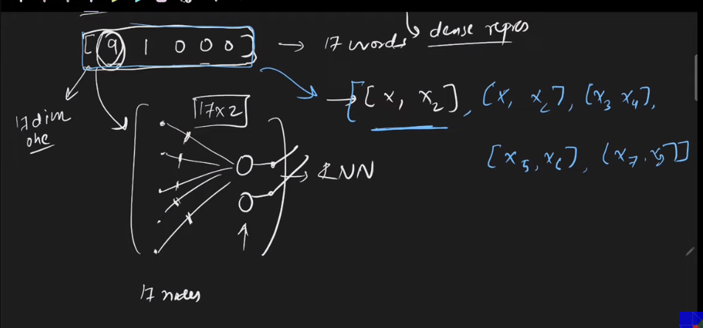
[9 1 0 0 0] ye aik review hai mtlb one data point, ab ho ga kiya hamaray total data mn 17 unique words hain, to word jo represented by 9 hai wo 17 dimensional vector mn convert ho ga or layer mn jaye ga, agay layer 2 outputs dy gi is word ky liye, or poray review ka data after applying embedding layer istrhan ka ho ga [[x1,x2],[x3,x4],[x5,x6],[x7,x8],[x9,x10]]

